## Tabellen

### Human Likeness Conditie

**Exclusie op onvolledigde data – participant nummer 24 verwijderd**

|  |  |  |  |  |
| --- | --- | --- | --- | --- |
|  |  | Gemiddelde | Variantie | Standaarddeviatie |
| Acceptability |  |  |  |  |
|  | Battle Robot | 4.265 | 5.157 | 2.271 |
|  | High Quality Man | 6.735 | 3.741 | 1.934 |
|  | Low Quality Man | 6.041 | 5.082 | 2.254 |
|  | Mannequin | 4.959 | 3.915 | 1.979 |
|  | Skeleton | 5.633 | 5.196 | 2.279 |
|  | Toy Robot | 5.122 | 3.943 | 1.986 |
|  | Zombie | 3.429 | 3.500 | 1.871 |
| Likeness |  |  |  |  |
|  | Battle Robot | 2.388 | 2.327 | 1.525 |
|  | High Quality Man | 7.345 | 3.731 | 1.932 |
|  | Low Quality Man | 6.857 | 4.708 | 2.170 |
|  | Mannequin | 3.633 | 3.821 | 1.955 |
|  | Skeleton | 6.286 | 4.417 | 2.102 |
|  | Toy Robot | 2.449 | 2.169 | 1.473 |
|  | Zombie | 4.408 | 4.622 | 2.150 |

### Acceptability Conditie

|  |  |  |  |  |  |  |
| --- | --- | --- | --- | --- | --- | --- |
|  | |  |  | Gemiddelde | Variantie | Standaarddeviatie |
| Static | |  |  |  |  |  |
|  | | Battle Robot |  |  |  |  |
|  | |  | Sb1 | 5.54 | 4.049 | 2.013 |
|  | |  | Sb2 | 5.62 | 3.914 | 1.978 |
|  | |  | Sb3 | 5.68 | 3.814 | 1.953 |
|  | | High Quality Man |  |  |  |  |
|  | |  | Sb1 | 6.94 | 3.159 | 1.777 |
|  | |  | Sb2 | 6.88 | 3.455 | 1.859 |
|  | |  | Sb3 | 7 | 3.306 | 1.818 |
|  | | Low Quality Man |  |  |  |  |
|  | |  | Sb1 | 5.74 | 5.217 | 2.284 |
|  | |  | Sb2 | 5.72 | 5267 | 2.295 |
|  | |  | Sb3 | 5.7 | 5.398 | 2.323 |
|  | | Mannequin |  |  |  |  |
|  | |  | Sb1 | 5.92 | 5.667 | 2.380 |
|  | |  | Sb2 | 5.88 | 5.455 | 2.335 |
|  | |  | Sb3 | 5.86 | 5.756 | 2.399 |
|  | | Skeleton |  |  |  |  |
|  | |  | Sb1 | 5.48 | 5.275 | 2.297 |
|  | |  | Sb2 | 5.46 | 5.274 | 2.296 |
|  | |  | Sb3 | 5.44 | 5.476 | 2.340 |
|  | | Toy Robot |  |  |  |  |
|  | |  | Sb1 | 6.86 | 4.000 | 2.000 |
|  | |  | Sb2 | 6.8 | 3.388 | 1.840 |
|  | |  | Sb3 | 6.7 | 3.765 | 1.940 |
|  | | Zombie |  |  |  |  |
|  | |  | Sb1 | 3.4 | 6.531 | 2.555 |
|  | |  | Sb2 | 3.52 | 6.785 | 2.605 |
|  | |  | Sb3 | 3.4 | 6.449 | 2.539 |
| Motion | |  |  |  |  |  |
|  | Natural |  |  |  |  |  |
|  |  | Battle Robot |  | 5.87 | 4.414 | 2.101 |
|  |  | High Quality Man |  | 6.703 | 3.895 | 1.974 |
|  |  | Low Quality Man |  | 5.757 | 4.573 | 2.138 |
|  |  | Mannequin |  | 5.84 | 5.566 | 2.359 |
|  |  | Skeleton |  | 5.37 | 5.431 | 2.330 |
|  |  | Toy Robot |  | 6.74 | 3.41 | 1.847 |
|  |  | Zombie |  | 3.427 | 6.165 | 2.483 |
|  | Distortion A |  |  |  |  |  |
|  |  | Battle Robot |  | 5.863 | 4.359 | 2.088 |
|  |  | High Quality Man |  | 6.64 | 4.238 | 2.059 |
|  |  | Low Quality Man |  | 5.68 | 4.568 | 2.141 |
|  |  | Mannequin |  | 576 | 5.728 | 2.393 |
|  |  | Skeleton |  | 5.303 | 5.597 | 2.366 |
|  |  | Toy Robot |  | 6.707 | 3.358 | 1.833 |
|  |  | Zombie |  | 3.33 | 5.887 | 2.426 |
|  | Distortion B |  |  |  |  |  |
|  |  | Battle Robot |  | 5787 | 4.469 | 2.115 |
|  |  | High Quality Man |  | 6.563 | 4.581 | 2.140 |
|  |  | Low Quality Man |  | 5.83 | 4.679 | 2.163 |
|  |  | Mannequin |  | 5.753 | 5.484 | 2.342 |
|  |  | Skeleton |  | 5.31 | 5.552 | 2.356 |
|  |  | Toy Robot |  | 6.627 | 3.646 | 1.909 |
|  |  | Zombie |  | 3.32 | 6.105 | 2.471 |
|  | Distortion C |  |  |  |  |  |
|  |  | Battle Robot |  | 5.817 | 4.351 | 2.086 |
|  |  | High Quality Man |  | 6.497 | 4.873 | 2.207 |
|  |  | Low Quality Man |  | 5.600 | 4.762 | 2.182 |
|  |  | Mannequin |  | 5.710 | 5.752 | 2.398 |
|  |  | Skeleton |  | 5.203 | 5.641 | 2.375 |
|  |  | Toy Robot |  | 6.62 | 3.688 | 1.920 |
|  |  | Zombie |  | 3.31 | 6.054 | 2.460 |
|  | Distortion D |  |  |  |  |  |
|  |  | Battle Robot |  | 5.727 | 4.654 | 2.157 |
|  |  | High Quality Man |  | 6.450 | 5.225 | 2.286 |
|  |  | Low Quality Man |  | 5.480 | 5.133 | 2.266 |
|  |  | Mannequin |  | 5.663 | 5.863 | 2.421 |
|  |  | Skeleton |  | 5.087 | 5.424 | 2.329hi |
|  |  | Toy Robot |  | 6.647 | 3.748 | 1.936 |
|  |  | Zombie |  | 3.247 | 5.966 | 2.442 |

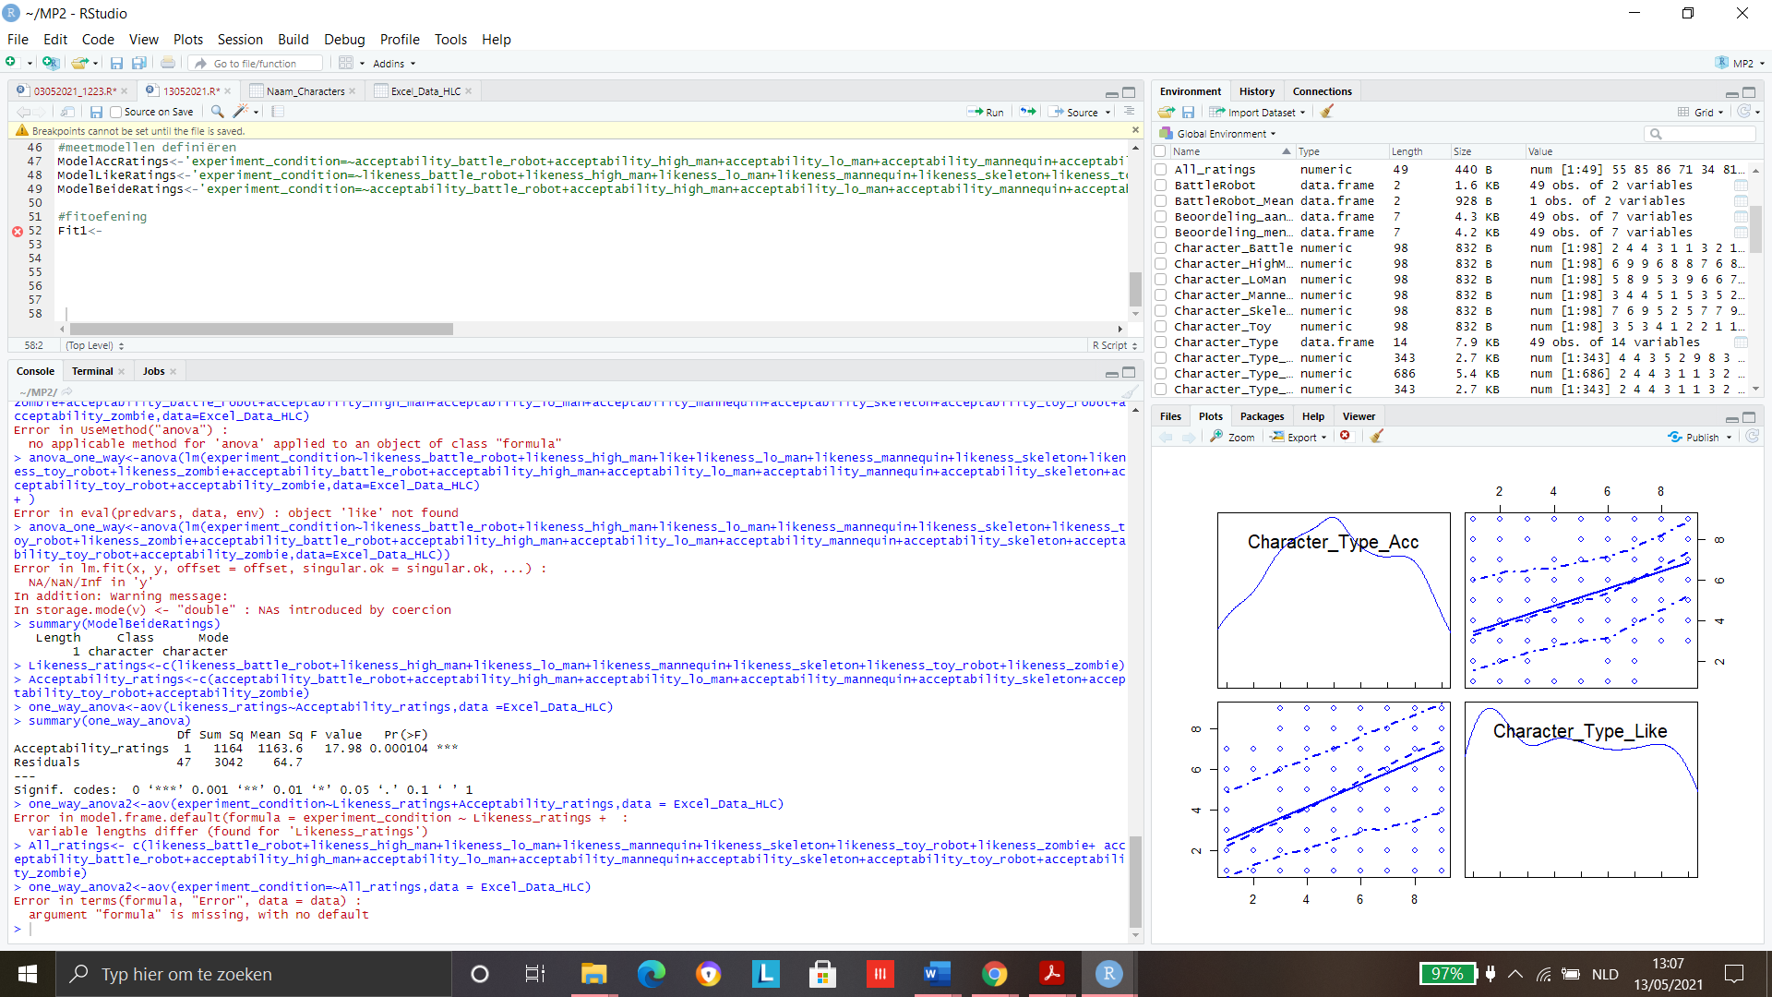*#oneway_anova hlc*

### #lineaire regressie 1 variabele (naïeve aanpak)

**To do 17/05:**

* Uitschrijven resultatensectie bovenstaande gegevens + sem?
* Exploratorische HLC analyse voorbereiden
* Exploratorische HLC analyse uitvoeren
* Confirmatorische analyse ACC voorbereiden + uitvoeren